Project on BILLING

Project Tittle: Billing on Samsung S25

Source code: python

Git hub link :  **https://github.com/sksam7860/billing_project.git**

BY: SAYEDBASHA

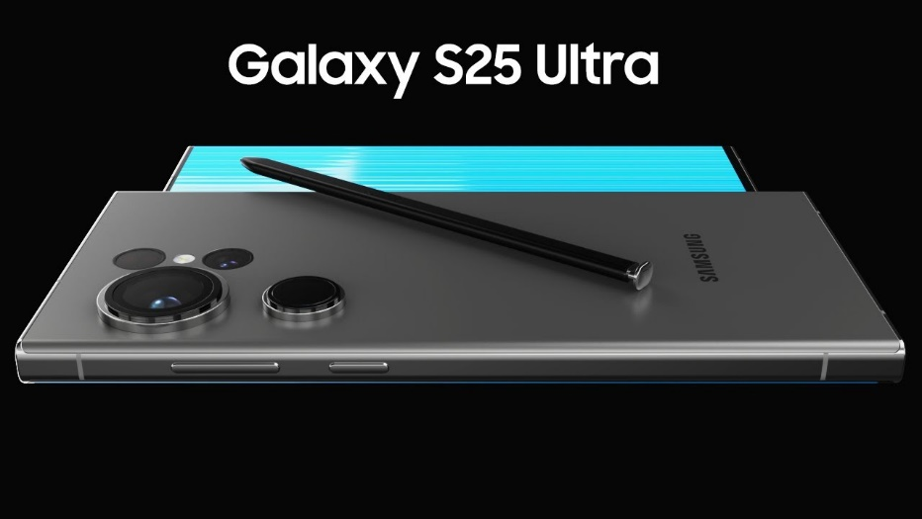

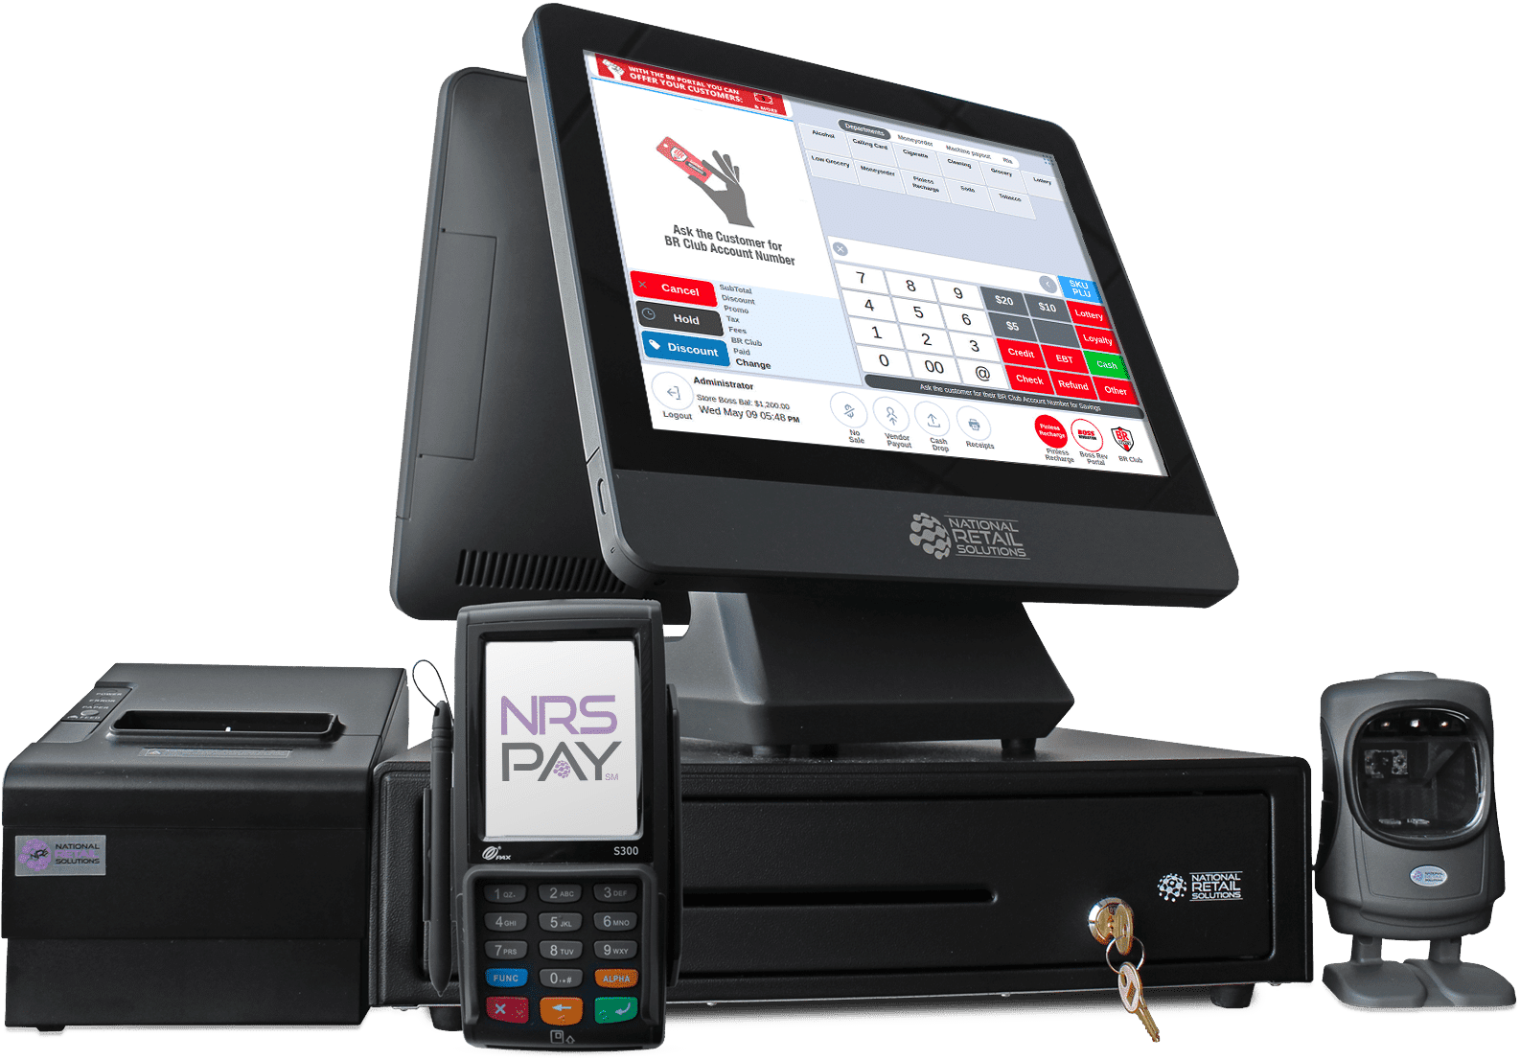

## Samsung Galaxy S25, S25+, and S25 Ultra:

* Release Date: February 7, 2025

* Display:

* S25: 6.2-inch Dynamic AMOLED 2X, FHD+ resolution, 120Hz adaptive refresh rate

* S25+: 6.7-inch Dynamic AMOLED 2X, QHD+ resolution, 120Hz adaptive refresh rate

* S25 Ultra: 6.9-inch Dynamic AMOLED 2X, QHD+ resolution, 120Hz adaptive refresh rate

* Processor: Snapdragon 8 Elite for Galaxy (in some regions, Exynos 2500 may be used)

* RAM: 12GB

* Storage:

* S25: 128GB, 256GB, 512GB

* S25+: 256GB, 512GB

* S25 Ultra: 256GB, 512GB, 1TB

* Rear Camera:

* S25 & S25+: Triple camera system

* 50MP Wide-angle

## Samsung S25 Billing Calculation

This document explains the billing process for purchasing Samsung S25 devices at a unit cost of ₹80,999. The calculation includes applicable GST taxes and discounts based on the quantity of items purchased.

### Pricing Details

* Unit Price (Samsung S25): ₹80,999
* GST Composition (Total 18%):
  + SGST: 9%
  + CGST: 9%

### Discount Structure Based on Quantity

Different discount rates are applied depending on the number of Samsung S25 units ordered:

* 2 to 5 units: 5% discount
* 6 to 10 units: 10% discount
* 11 to 20 units: 18% discount
* 21 to 40 units: 24% discount
* Any other quantity (including 1 or above 40): 2% discount

### Billing Calculations

The total cost before taxes and discount is calculated as:

\begin{math} \text{Total Cost} = \text{Unit Price} \times \text{Number of Units} \end{math}

SGST and CGST amounts are computed as 9% each on the total cost:

\begin{math} \text{SGST} = \text{Total Cost} \times 0.09 \quad \text{and} \quad \text{CGST} = \text{Total Cost} \times 0.09 \end{math}

The discount amount is:

\begin{math} \text{Discount} = \text{Total Cost} \times \text{Applicable Discount Rate} \end{math}

Finally, the amount payable by the customer is given by:

\begin{equation} \text{Payable Amount} = \text{Total Cost} + \text{SGST} + \text{CGST} - \text{Discount} \end{equation}

### Summary

At checkout, customers input the number of Samsung S25 units they want to purchase. The system automatically calculates the subtotal, applies the correct GST, deducts any quantity-based discount, and outputs the final payable amount. This structured billing ensures clarity and transparency in the transaction.

 CODE OF BACK END:

S25_samsung_cost = 80_999

# GST Percentages (Total 18%: 9% SGST + 9% CGST)

SGST = 9 / 100

CGST = 9 / 100

print("------- We are selling Samsung S25 --------")

print("------- Each costs ₹80,999 ---------------")

# Number of items required by the customer

required_items = int(input("No. of required items: "))

# Apply discount based on quantity

if 2 <= required_items <= 5:

discount = 5 / 100

elif 6 <= required_items <= 10:

discount = 10 / 100

elif 11 <= required_items <= 20:

discount = 18 / 100

elif 21 <= required_items <= 40:

discount = 24 / 100

else:

discount = 2 / 100

# Calculations

S25_total_cost = required_items * S25_samsung_cost

S25_SGST = S25_total_cost * SGST

S25_CGST = S25_total_cost * CGST

S25_discount_amount = S25_total_cost * discount

# Final total cost

total_cost = S25_total_cost + S25_SGST + S25_CGST - S25_discount_amount

# Output

print("\n------------ Billing Summary --------------------")

print(" Total Samsung Cost : ₹:", S25_total_cost)

print(" SGST (9%) : ₹:",S25_SGST)

print(" CGST (9%) : ₹:", S25_CGST)

print(" Discount Applied (discount*100:.0f%) : ₹:", S25_discount_amount)

print("-------------------------------------------------")

print(" Total Payable Amount : ₹:", total_cost)

print("-------------------------------------------------")

print(".<.<.< THANK YOU AND VISIT AGAIN >.>.>.")

**link to see the code :https://github.com/sksam7860/billing_project.git**

**THANK YOU**